**INTERSHIP REPORT**

**ON**

**“UBER DATA ANALYSIS”**

**BY :-**

**NAME:- MRUDULA VASISTA SS**

**USN:- 1EW18IS056**

**COLLEGE:- EAST WEST INSTITUTE OF TECHNOLOGY**

**DOMAIN:- MACHINE LEARNING**

**COMPANY NAME:- INFIDATA TECHNOLOGIES**

**DURATION:- 30/08/2021 – 30/09/2021**

**TABLE OF CONTENTS**

|  |  |  |
| --- | --- | --- |
| **Ch.No.** | **Chapter Name** | **Pg. No** |
| **1.** | **Company Profile** | 3-8 |
| **2.** | **Internship Domain** | 9-19 |
| **3.** | **Task Performed** | 19-22 |
| **4.** | **Reflection Notes** | 23-25 |
| **5.** | **Results and Internship Outcomes** | 26-27 |
| **6.** | **Conclusion** | 28 |

**CHAPTER 1**

**COMPANY PROFILE**

Infidata Technologies is a dynamic start-up company. The foundation to Infidata technologies is built on the key focus area of domain expertise in industry verticals, customer focus by quickly aligning to client needs and company’s unique delivery model is well executed through collaborative network of partners.

**1.1 Introduction**

Infidata technologies an ISO 9001: 2015 Certified Company (Accredited by International

Accreditation Service: IAS) headquartered in “silicon valley” of India Bengaluru started in the year 2015. Company is highly specialized in the design and development of website, software application development, Mobile application development, E-Commerce solution and more. Company has a team of expert’s professional works on the latest software tools and technologies to give the best and promising services to the customers. Company is equipped with the state-of-art work station in the software application development.

**Vision**

To become a leading performer and grow as a major IT service provider, in providing quality Web application, Software Development solutions and corporate training in the competitive global marketplace.

**Mission**

To ensure strategic planning with quality products and Profitable growth through customer service, innovation, quality and commitment.

**1.2 Team**

Infidata Technologies is a team of experienced professionals providing a wide range of complex software and web application development services. The energetic professionals with vast experience who are working in almost all technologies & spheres of IT.

**1.3 Services**

Infidata Technologies offer the services in the following areas:

* Enterprise Application Services
* Web designing and Development
* Mobile Application Development
* Internet of Things
* Training Services

**1.3.1 Enterprise Application Services**

An enterprise application is a software system platform designed to operate in a corporate environment such as business or government.EA software services include online shopping and payment processing, interactive product catalogs, computerized billing systems, security, content management, IT service management, content switching modules, resource planning, business intelligence, human resource management, manufacturing, application integration, forms automation, sales force automation, enterprise resource planning and business process management. EA also includes news relevant to IT compliance, business intelligence, office productivity suites, enterprise resource planning etc.

**1.3.2 Web designing and Development**

The web development process includes web design, web content development, client-side/server-side scripting and network security configuration, among other tasks.

Web development ranges from creating plain text pages to complex web-based applications, social network applications and electronic business applications.

The web development hierarchy is as follows:

* Client-side coding
* Server-side coding
* Database technology

**1.3.3 Mobile Application Development**

A mobile application, most commonly referred to as an app, is a type of application software designed to run on a mobile device, such as a smartphone or tablet computer.

Mobile applications frequently serve to provide users with similar services to those accessed on PCs. Apps are generally small, individual software units with limited function.

Vendors usually offer a mobile application platform to clients that want to go mobile or enter the mobile market. The platform includes migration tools and resources that support a mobile interface, or a development environment that allows creating new apps aimed at the Apple and Android markets. A platform approach to mobile application development helps provide a comprehensive model with tool suites that are accessible to developers and other users.

**1.3.4 Internet of Things**

Internet of things (IoT) is a computing concept that describes the idea of everyday physical objects being connected to the internet and being able to identify themselves to other devices. Most people think about being connected in terms of computers, tablets and smartphones. IoT describes a world where just about anything can be connected and communicate in an intelligent fashion. In other words, with the internet of things, the physical world is becoming one big information system.

**1.3.5 Training Services**

The training programs that are organized by us are of the best standards. We have some of the best trainers who conduct these programs. All these trainers have been in the industry for a long period. They know the problems faced by the industries. They have the total firsthand knowledge. Their rich experience is something that you would gain from. They can train students/ employee step by step. We offers training on Java, Web, C# & .Net, Python, Machine Learning, Mobile Application Development, Software Testing and More.

**1.4 Company Products**

* ECAMS
* Billing Software
* ERP Solution
* Retail Store
  1. **Our Clients**
* Streams Inc
* Vishnu Enterprises
* Deepthi Engineering
* JB Transport India
* BreakDQ
* SJCPU
* Rbits Technologies

**ABOUT THE DEPARTMENT**

Infidata Technologies provided an internship in the department of Machine Learning division. The Objective is the development of new model and technology ensuring that the development of applications with the highest quality.

**Machine Learning Department**

Machine Learning organizes a practical procedure and approach in application development. Infidata technologies want to streamline their internal departments and functions, operations, sales and project management, etc. and want to take advantage of a ML based applications flexibility and versatility, by moving away from the traditional web application platform to the smart application platform and want to gain more clients for better service their current clients by offering convenient services and solutions online to build more smart applications to offer innovative services or solutions to online users and businesses

The structure helps produce best practice coding with consistent logic and coding standards, and provides other developers the ability to become familiar with the code in a short time. Builds are based on the module, libraries and tools, allowing programmers to easily share libraries and implement complex functionalities and features in a fast and efficient manner.

**Tips for ML application development**

The following list of procedures and documents provide a good outline for a ML Application Lifecycle and Process:

**1. Product Search**

To give users relevant information according to their pursuit of the eCommerce app, our developers implement the whole set of ML tools such as ranking, query understanding and expansion related questions and so on.

For instance, for product ranking, we use customer information about the click-through rate or product sell-through rate. Additionally, we analyze behavioral data during searching and the purchase process. Drawing on this, we create graphs between different goods and queries.

Another interesting tool is query intent detection. It comes from understanding the user`s portrait, his search history, and semantics outcome.

**2. Product Recommendation and Promotions**

The recommendation system is built on the collaborating filtering method. The App Solutions team together with our partner Softcube provide clients with significant data service for smart recommendations and digital merchandising (“this item fits…” ).

The system is built upon the site content analysis, user behavior or purchase patterns, and even upon the business logic of the enterprise. Predictive analytics makes the challenge easier, and recommendations become even more relevant with time. Such technology gives up to 7-12% from the same traffic.

**3. Trend forecasting and analytics**

The eCommerce enterprises, especially those, working in the fashion industry, always have a lack of information to understand and quickly respond to the latest trends. They have information about past season sales and upcoming tendencies. But between these two sources, there is a huge gap of missing opportunities.

Big data ML allows aggregating the trends and sales information from different open sources (inspirational blogs, social media, designer reports) and give predictions in real time. The same issue could be implemented in price management.

**4. Fraud detection and prevention**

One way or another, every eCommerce company has faced this challenge. The annual fraud costs reached the point of $32 billion which is 38% more than the year before. Machine learning plays a critical role in building a defense system. It involves the ongoing monitoring

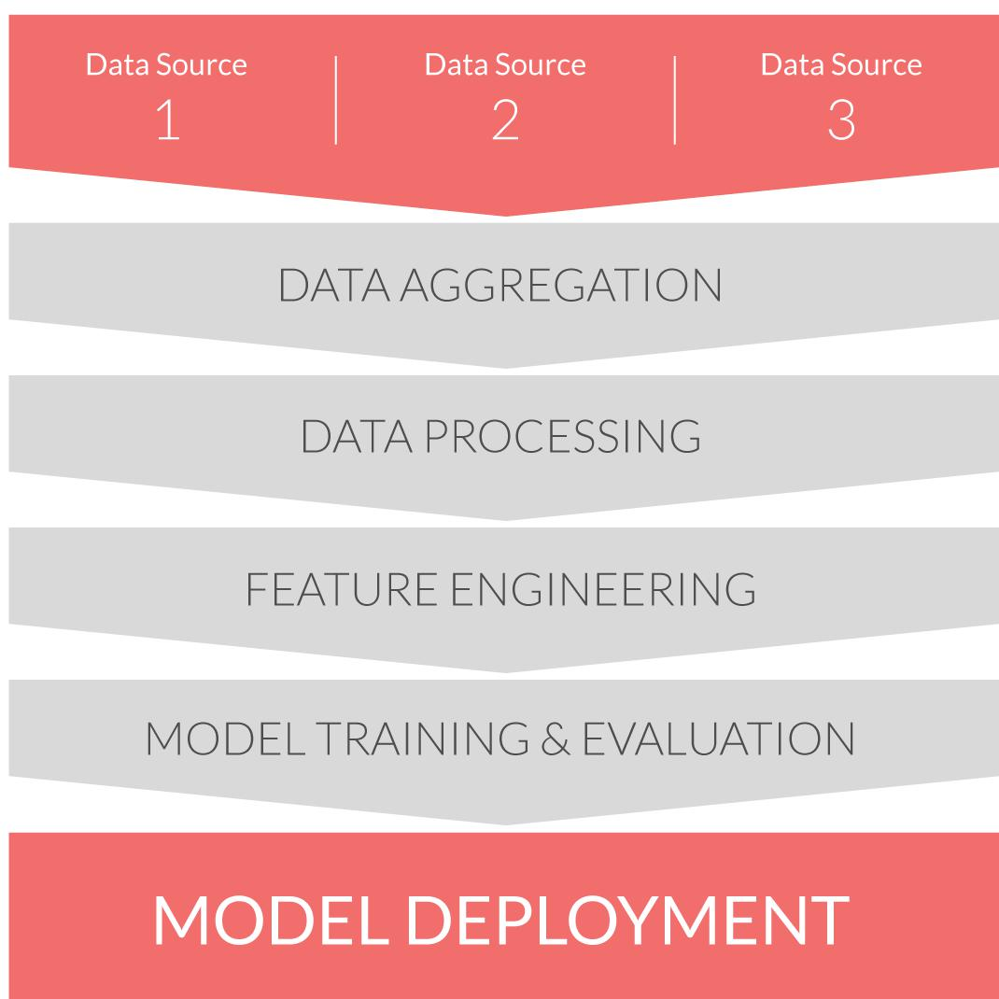of online activities and triggering of alarms. Here is the general workflow of “abnormal” behavior patterns detection:

**CHAPTER 2**

**INTERNSHIP DOMAIN**

**2.1 Introduction**

The technology that promises to bring massive changes to the world next years is ML. Machine learning is a subfield of the Artificial Intelligence research and got the highest spotlight in business.

ML represents a new era in software development where computers, gadgets, and other devices do not require special programming to complete tasks anymore. Instead, they can collect and analyze information that is needed to draw appropriate conclusions and learn during program performance. Now machines can accumulate previous experience in order to make decisions as it occurs among human beings. Of course, the process of learning requires special algorithms that would “teach” machines. That is why, at The App Solutions, we use machine learning in [mobile app development.](https://theappsolutions.com/services/native-app-development/)

To understand the scale of ML industry, let's take a general outlook on the Artificial Intelligence market. According to Bank of America Merrill Lynch, over the next five years, the market will extend to $153 billion compared to $58 billion in 2014.

Venture Scanning gives an infographic that summarizes the Artificial Intelligence market and shows funding of every category. The chart shows that ML applications category is leading with over $2 billion market share. This is three times more than the total funding of the next Natural Learning Processing group.

**Basic Difference in ML and Traditional Programming?**

* **Traditional Programming :** We feed in DATA (Input) + PROGRAM (logic), run iton machine and get output.
* **Machine Learning :** We feed in DATA(Input) + Output, run it on machine duringtraining and the machine creates its own program(logic), which can be evaluated while testing.

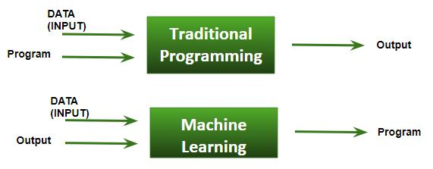

**What does exactly learning means for a computer?**

A computer is said to be learning from Experiences with respect to some class of Tasks, if its performance in a given Task improves with the Experience.

A computer program is said to learn from experience E with respect to some class of tasks T and performance measure P, if its performance at tasks in T, as measured by P, improves with experience E

Example: playing checkers.

E = the experience of playing many games of checkers

T = the task of playing checkers.

P = the probability that the program will win the next game

In general, any machine learning problem can be assigned to one of two broad classifications:

Supervised learning and Unsupervised learning.

**How things work in reality:-**

Talking about online shopping, there are millions of users with unlimited range of interests with respect to brands, colors, price range and many more. While online shopping, buyers tend to search for a number of products. Now, searching a product frequently will make buyer’s Facebook, web pages, search engine or that online store start recommending or showing offers on that particular product. There is no one sitting over there to code such task for each and every user, all this task is completely automatic. Here, ML plays its role. Researchers, data scientists, machine learners build models on machine using good quality

and huge amount of data and now their machine is automatically performing and even improving with more and more experience and time.

Traditionally, advertisement was only done using newspapers, magazines and radio but now technology has made us smart enough to do Targeted advertisement (online ad system) which is a way more efficient method to target most receptive audience.

Even in health care also, ML is doing a fabulous job. Researchers and scientists have prepared models to train machines for detecting cancer just by looking at slide – cell images. For humans to perform this task it would have taken a lot of time. But now, no more delay, machines predict the chances of having or not having cancer with some accuracy and doctors just have to give a assurance call, that’s it. The answer to – how is this possible is very simple -all that is required, is, high computation machine, large amount of good quality image data, ML model with good algorithms to achieve state-of-the-art results.

Doctors are using ML even to diagnose patients based on different parameters under consideration.

You all might have use IMDB ratings, Google Photos where it recognizes faces, Google Lens where the ML image-text recognition model can extract text from the images you feed in, Gmail which categories Email as social, promotion, updates or forum using text classification,which is a part of ML.

**How ML works?**

Gathering past data in the form of text file, excel file, images or audio data. The more better the quality of data, the better will be the model learning Data Processing – Sometimes, the data collected is in the raw form and it needs to be rectified.

Example: if data has some missing values, then it has to be rectified. If data is in the form of text or images then converting it to numerical form will be required, be it list or array or matrix. Simply, Data is to be made relevant and understandable by the machine

Building up models with suitable algorithms and techniques and then training it.

Testing our prepared model with data which was not feed in at the time of training and so evaluating the performance – score, accuracy with high level of precision.

**Prerequisites to learn ML:**

* Linear Algebra
* Statistics and Probability
* Calculus
* Graph theory
* Programming Skills – Language such as Python, R, MATLAB, C++ or Octave

**2.2 Tools & Technologies Used**

(Note: Mention the tools and technologies used during your internship)

* + Microsoft Azure
  + ai-one
  + DiffBlue
  + Google’s TensorFlow
  + Amazon Web Services
  + Protege
  + Apache Spark MLlib
  + [Nervana Neon](https://www.intelnervana.com/neon/)
  + OpenNN
  + Apache Mahout

1. **Microsoft Azure**

Azure ML is built on top of the machine learning capabilities of several Microsoft products and services. It shares many of the real-time predictive analytics of the new personal assistant in Windows Phone called Cortana.

Azure ML also uses proven solutions from Xbox and Bing. Outshining Nate Silver’s lauded FiveThirtyEight blog, Bing Predicts recently astonished many by correctly forecasting the results of more than 95% of the US mid-term elections. Thus, it might be worth checking out Azure ML to see what its powerful cloud-based predictive analytics can do for you.

**2. ai-one**

Claiming to be ‘biologically inspired intelligence’, ai-one lets developers create intelligent assistants within most software applications

Ai-one’s ‘Analyst Toolbox’ provides a document library, building agents and APIs for developers. Ai-one can essentially turn data into generalised rule sets, enabling lots of in-depth AI and machine learning structures.

**3. DiffBlue**

Diffblue’s core AI builds an exact mathematical model of any code base. This model allows a very deep semantic understanding of what a program is trying to do. Founded by Daniel Kroening at the University of Oxford, DiffBlue is a dedicated code automation platform. And it’s a simple but extremely useful one at that.

Its aim is to locate bugs, refactor code, perform test writing and find and fix weaknesses in code, all done via automation.

**4. Google’s TensorFlow**

TensorFlow is an open source software library for numerical computation using data flow graphs. Nodes in the graph represent mathematical operations, while the graph edges represent the multidimensional data arrays (tensors) communicated between them. The flexible architecture allows you to deploy computation to one or more CPUs or GPUs in a desktop, server, or mobile device with a single API.

TensorFlow was originally developed by researchers and engineers working on the Google Brain Team within Google’s Machine Intelligence research organization for the purposes of conducting machine learning and deep neural networks research, but the system is general enough to be applicable in a wide variety of other domains as well.

**5. Amazon Web Services**

At its re:invent conference in San Francisco last year, Amazon Web Services (AWS) announced three new artificial intelligence toolkits for developers. AWS Rekognition uses AI to add image interpretation and facial recognition to apps, which is often used for biometric security features. Polly uses AI to automate voice to written text across 47 voices in 24 languages.

While Lex is the open source engine behind Amazon’s personal assistant Alexa, allowing developers to integrate chatbots into web and mobile applications.

**6. Protege**

Although enterprise-focused, Protege has a suite of open source tools ideal for developers to create ‘knowledge-based applications with ontologies’.

Aimed at both experts and (somewhat) beginners, Protege lets developers create, upload, modify and share applications. Protege also houses an active community, making troubleshooting simple and collaboration optimised.

**7. Apache Spark MLlib**

MLlib is the machine learning library that is provided with Apache Spark, the in memory cluster based open source data processing system. It features a large database of algorithms focusing on classification, regression, clustering and collaborative filtering.

It is designed for simplicity, scalability, and easy integration with other tools. With the scalability, language compatibility, and speed of Spark, data scientists can solve and iterate through their data problems faster.

**8. Nervana Neon**

Nervana and Intel have joined forces to build the next generation of intelligent agents and applications and Neon is its open source Python-based machine learning library.

Founded in 2014, Neon lets developers build, train and deploy deep learning technologies in the cloud. Neon has lots of video tutorials and a ‘model zoo’ which houses pre-trained algorithms and example scripts.

**9. OpenNN**

OpenNN is an open source class library written in C++ which implements neural networks. This open neural networks library was formerly known as Flood.

It includes lots of documentation and tutorials including an introduction to neural networks, although OpenNN is aimed at developers with lots of experience with artificial intelligence.

The package comes with unit testing, many examples and extensive documentation. It provides an effective framework for the research and development of neural networks algorithms and applications.

**10. Apache Mahout**

Apache Mahout is a library of scalable machine-learning algorithms, implemented on top of Apache Hadoop and using the MapReduce paradigm.

Once big data is stored on the Hadoop Distributed File System (HDFS), Mahout provides the data science tools to automatically find meaningful patterns in those big data sets. The Apache Mahout project aims to make it faster and easier to turn big data into big information.

**2.3 Tools Used:**

**List of tools used during internship**

* Jupyter Notebook
* Python

**Jupyter Notebook**

Jupyter Notebook (formerly IPython Notebooks) is a web-based interactive computational environment for creating Jupyter notebooks documents. The "notebook" term can colloquially make reference to many different entities, mainly the Jupyter web application, Jupyter Python web server, or Jupyter document format depending on context. A Jupyter Notebook document is a JSON document, following a versioned schema, and containing an ordered list of input/output cells which can contain code, text (using Markdown), mathematics, plots and rich media, usually ending with the ".ipynb" extension.

A Jupyter Notebook can be converted to a number of open standard output formats (HTML, presentation slides, LaTeX, PDF, ReStructuredText, Markdown, Python) through "Download As" in the web interface, via the nbconvert library or "jupyter nbconvert" command line interface in a shell.

To simplify visualisation of Jupyter notebook documents on the web, the nbconvert library is provided as a service through NbViewer which can take a URL to any publicly available notebook document, convert it to HTML on the fly and display it to the user.

**IPython Notebook interface**

Jupyter Notebook provides a browser-based REPL built upon a number of popular open-source libraries:

* IPython
* ØMQ
* Tornado (web server)
* jQuery
* Bootstrap (front-end framework)
* MathJax

Jupyter Notebook can connect to many kernels to allow programming in many languages. By default Jupyter Notebook ships with the IPython kernel. As of the 2.3 release[9][10] (October 2014), there are currently 49 Jupyter-compatible kernels for as many programming languages, including Python, R, Julia and Haskell.

The Notebook interface was added to IPython in the 0.12 release (December 2011), renamed to Jupyter notebook in 2015 (IPython 4.0 – Jupyter 1.0). Jupyter Notebook is similar to the notebook interface of other programs such as Maple, Mathematica, and SageMath, a computational interface style that originated with Mathematica in the 1980s. According to The Atlantic, Jupyter interest overtook the popularity of the Mathematica notebook interface in early 2018.

Jupyter Notebook is a web application that allows you to create and share documents that contain:

* live code (e.g. Python code)
* visualizations
* explanatory text (written in markdown syntax)

Jupyter Notebook is great for the following use cases:

* learn and try out Python
* data processing / transformation
* numeric simulation
* statistical modeling
* machine learning.

**Python**

Python is an interpreted, high-level, general-purpose programming language. Created by Guido van Rossum and first released in 1991, Python has a design philosophy that emphasizes code readability, notably using significant whitespace. It provides constructs that enable clear programming on both small and large scales. Van Rossum led the language community until stepping down as leader in July 2018.

Python features a dynamic type system and automatic memory management. It supports multiple programming paradigms, including object-oriented, imperative, functional and procedural, and has a large and comprehensive standard library.

Python interpreters are available for many operating systems. CPython, the reference implementation of Python, is open source software and has a community-based development model, as do nearly all of Python's other implementations. Python and CPython are managed by the non-profit Python Software Foundation.

**It is used for:**

* web development (server-side),
* software development,
* mathematics,
* system scripting.

**What can Python do?**

* Python can be used on a server to create web applications.
* Python can be used alongside software to create workflows.
* Python can connect to database systems. It can also read and modify files.
* Python can be used to handle big data and perform complex mathematics.
* Python can be used for rapid prototyping, or for production-ready software development.

**Why Python?**

* Python works on different platforms (Windows, Mac, Linux, Raspberry Pi, etc).
* Python has a simple syntax similar to the English language.
* Python has syntax that allows developers to write programs with fewer lines than some other programming languages.

* Python runs on an interpreter system, meaning that code can be executed as soon as it is written. This means that prototyping can be very quick.
* Python can be treated in a procedural way, an object-orientated way or a functional way.

**Good to know**

* The most recent major version of Python is Python 3, which we shall be using in this tutorial. However, Python 2, although not being updated with anything other than security updates, is still quite popular.
* In this tutorial Python will be written in a text editor. It is possible to write Python in an Integrated Development Environment, such as Thonny, Pycharm, Netbeans or Eclipse which are particularly useful when managing larger collections of Python files.

**Python Syntax compared to other programming languages**

* Python was designed to for readability, and has some similarities to the English language with influence from mathematics.
* Python uses new lines to complete a command, as opposed to other programming languages which often use semicolons or parentheses.
* Python relies on indentation, using whitespace, to define scope; such as the scope of loops, functions and classes. Other programming languages often use curly-brackets for this purpose.

**CHAPTER 3**

**TASK PERFORMED**

**PROJECT TITLE: UBER DATA ANALYSIS**

**3.1 Introduction to Project**

The working of an Uber dataset, which contains data produced by Uber for New York City. Uber is defined as a P2P platform. The platform links you to drivers who can take you to your destination. The dataset includes primary data on Uber pickups with details including the date, time of the ride as well as longitude-latitude information, Using the information, the paper explains the use of the k-means clustering algorithm on the set of data and classify the various parts of New York City.

Since the industry is booming and expected to grow shortly. Effective taxi dispatching will facilitate each driver and passenger to reduce the wait time to seek out one another. The model is employed to predict the demand on points of the city.

The Uber platform connects you with drivers who can take you to your destination or location. This dataset includes primary data on Uber collections with details that include the date, time of travel, as well as information on longitude and latitude in San-Francisco and has operations in over 900 metropolitan areas worldwide.

The prediction of the frequency of trips of data is by implementing a part of k-means clustering algorithm The standard algorithm describes the maximum variance within the group as the number of square distances Euclidean distances between the points and the corresponding centroid.

**3.2 Software/Hardware Req****uirements:**

Software Requirement:

* Python
* Anaconda Navigator
* Jupyter notebook

Hardware Requirement:

* OS : Ubuntu, Windows 7 (onwards)
* RAM : 2GB
* ROM : 500GB
* Processor : P4

**3.3. Modules Description**

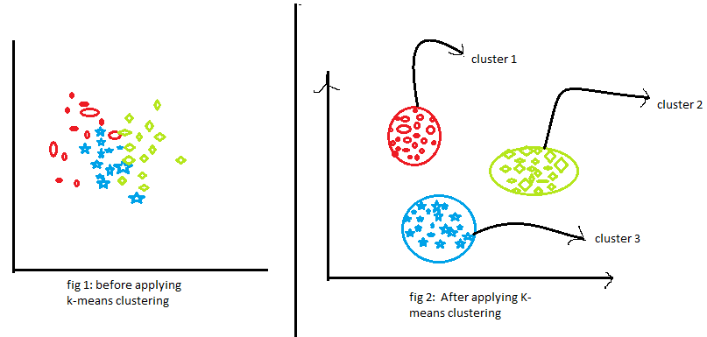

**What is K-Means clustering algorithm?**

K-means clustering is a type of unsupervised learning, which is used when you have unlabeled data (i.e., data without defined categories or groups). The goal of this algorithm is to find groups in the data, with the number of groups represented by the variable K.

The algorithm works iteratively to assign each data point to one of K groups based on the features that are provided. Data points are clustered based on feature similarity

The results of the K-means clustering algorithm are:

1. The centroids of the K clusters, which can be used to label new data

2. Labels for the training data (each data point is assigned to a single cluster)

Rather than defining groups before looking at the data, clustering allows you to find and analyze the groups that have formed organically. The "Choosing K" section below describes how the number of groups can be determined. Each centroid of a cluster is a collection of feature values which define the resulting groups. Examining the centroid feature weights can be used to qualitatively interpret what kind of group each cluster represents.

This introduction to the K-means clustering algorithm covers:

• Common business cases where K-means is used

• The steps involved in running the algorithm

• A Python example using delivery fleet data

**K-means clustering pseudocode:**

## K-Means Clustering

1. Choose the number of clusters(K) and obtain the data points

2. Place the centroids c_1, c_2, ..... c_k randomly

3. Repeat steps 4 and 5 until convergence or until the end of a fixed number of iterations

4. for each data point x_i:

- find the nearest centroid(c_1, c_2 .. c_k)

- assign the point to that cluster

5. for each cluster j = 1..k

- new centroid = mean of all points assigned to that cluster

6. End

**How to Choose K??**

There would be some instances where we would not know the number of clusters. Then, how can we choose the value for K??? There is a way called **the Elbow method**. In this method, you choose a different number of clusters and start plotting the within-cluster distance to the centroid. The graph looks as below.

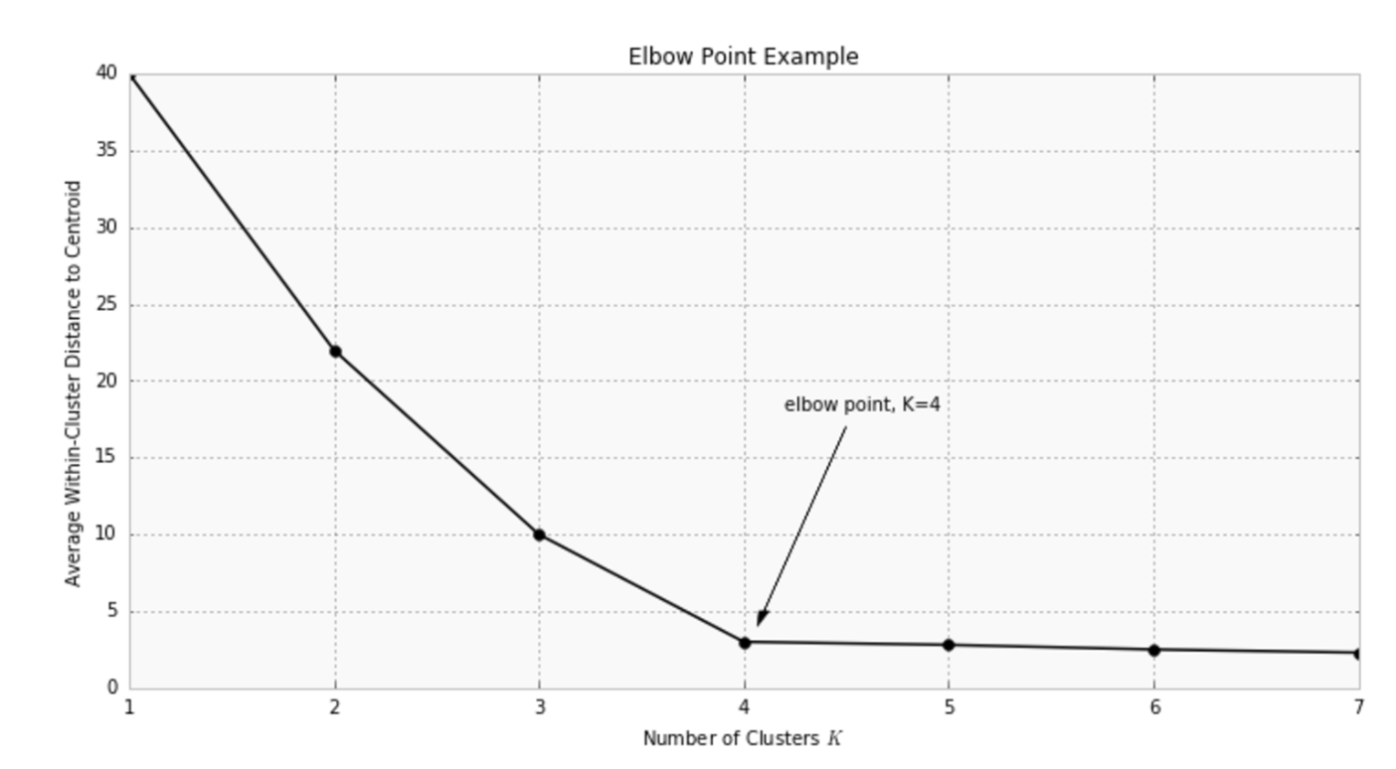

From the above graph we can infer that at k=4, the graph reaches an optimum minimum value. Even though the within-cluster distance decreases after 4, we would be doing more computations. Which is just analogous to the law of diminishing returns. Therefore, we choose a value of 4 as the optimum number of clusters. The reason it is named the elbow method is that the optimum number of clusters would represent an elbow joint!

**CHAPTER 4**

**REFLECTION NOTES**

**Note:**

I did my internship in the field of Machine Learning. Being a BE final year ISE student, I had to learn things in this domain. Just when I thought that the entire fun might be sucked out whilst going virtual, the Infidata virtual internship program changed my viewpoint entirely. It remained the same amazing program but in the comfort of your own home, how better can this even get?. My virtual internship experience has been seamless and rewarding. This one was a new experience for me, but the support from my mentor means that I don't miss out on anything. Every day I learnt and did something new, and the mentor always used to be there if I need help or had any doubts regarding the topics or project. This internship is a definite highlight of my UG course!. Not only am I working on a project but I'm also constantly building my network and skills through power hour sessions with amazing mentor.

**ACTIVATES DURING INTERNSHIP**

**Week 1 Activities**

* Introduction to ML
* Domain Training
* Training on Python
* Assignment

**Week 2 Activities**

* Training on statistics.
* More use of python libraries.
* Assignment on stats.

**Week 3 Activities**

* Training on ML.
* Algorithms of ML.
* Models in ML
* Assignment on ML
* Project Work introduction
* Activities on Model building

**Week 4 Activities**

* Project Based Activities
* Assessment Test
* Internship Project Work Presentation
* Internship Report Preparat

**Chapter 5**

**RESULTS AND INTERNSHIP OUTCOMES**

**5.1 Elbow plot**

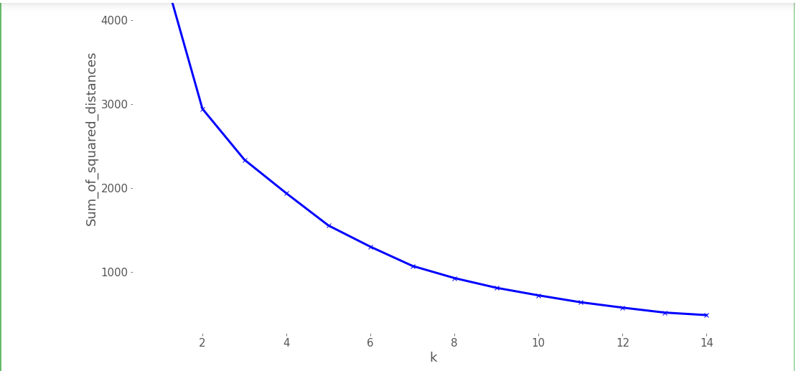

Figure No. 5.1

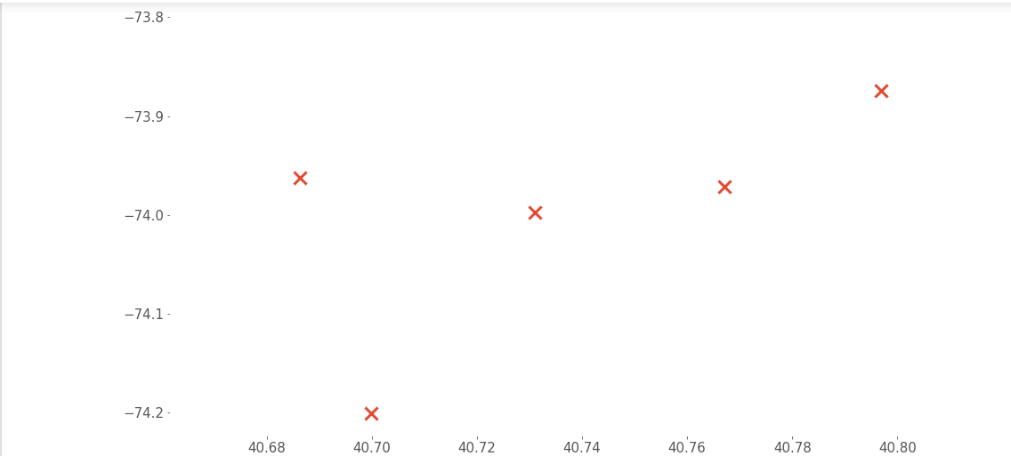**5.2 Scatter plot**

Figure No. 5.2

**5.3 Bar Graph**

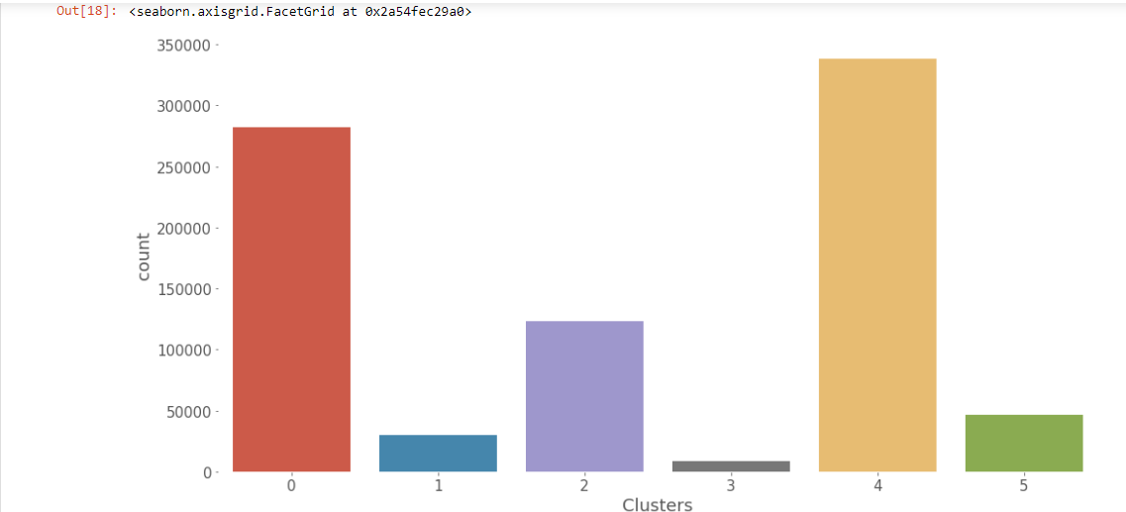

Figure No.5.3

**5.4 Google Map**

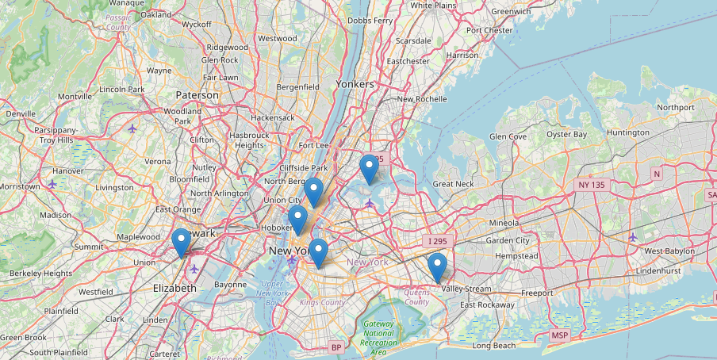

Figure No. 5.4

**CHAPTER 5**

**CONCLUSION**

Machine learning and artificial intelligence essentially empower the mobile application with enough customization features to make it more useful, efficient and effective. These technologies in accordance with the latest style are fast and safe.So it is a good idea to employ these technologies for your next mobile app development project. It is one of those defined limits that differentiate your application from that of your competitors.Now if you are looking to develop a mobile application with the necessary impulse of AI and ML for your business and make it jump.

There is likely room for further improvement, but this is a big improvement over the best decision tree error of 250,000. There are parameters which allow you to change the performance of the Random Forest much as we changed the maximum depth of the single decision tree. But one of the best features of Random Forest models is that they generally work reasonably even without this tuning.

**REFERENCES**

[1] <https://towardsdatascience.com>

[2] <https://www.geeksforgeeks.org>

[3] <https://stackoverflow.com>